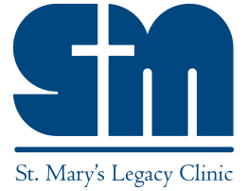
St. Mary’s Legacy Clinic
Extending the Healing Ministry of Jesus to East Tennessee

GIFTS OF STOCK

Thank you for your desire to make a gift of stock to St. Mary’s Legacy Clinic.
The instructions below have been published by the Office of Stewardship and Development to complete your transaction in the most timely and efficient manner possible. ______________________________________________________________________________

1. Please provide the below information to your broker or financial advisor:
Account Name: St. Mary’s Legacy Clinic – TAX ID#46-2331706
DTC #: XXXX
Account Number: XXXXX
Mailing Address: St. Mary’s Legacy Clinic
805 S. Northshore Dr.
Knoxville, TN 37919
Phone Number: (865) 212-5570
Contact Name: Martin Vargas

2. Please email or call to provide your name and contact information, name and number of shares of transfer, and intention/designation of your gift.
Contact Name: Martin Vargas, Executive Director
Phone Number: (865)212-5570
Email Address: stewardship@dioknox.org
3. You will receive a Gift of Stock Substantiation Form for your tax purposes.
Please note: To be recorded as a current calendar year donation, the securities must be received by UBS by December 31st. A gift transferred by the donor’s broker before December 31st, but received by UBS in January will not qualify as a current calendar year donation. On occasion, transfers are not completed within the same day due to unforeseen circumstances, particularly at year’s end.

