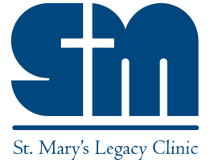
St. Mary’s Legacy Clinic
Extending the Healing Ministry of Jesus to East Tennessee

Donor Advised Funds (DAFs)

Recommending a gift to St. Mary’s Legacy Clinic through your donor advised fund (DAF) is simple. You can donate directly to the clinic by providing the following information to the sponsoring organization of your fund.
NOTE: Each organization will have the appropriate forms to complete these donations, which you can usually access through an online portal or working with your fund advisor. Your sponsoring organization can then complete the transaction to distribute the funds to SMLC. Occasionally some funds may limit the scope of the organizations that can be supported by your donor advised fund, please verify with your sponsoring organization or fund advisor for limitations or restrictions when making a donation to a religious organization.

Information to Make a Donor Advised Fund Gift
Legal Name: St. Mary’s Legacy Clinic
Federal Tax ID: 62-1357183
Mailing Address: St. Mary’s Legacy Clinic 805 S. Northshore Dr. Knoxville, TN 37919-7551

Name of the fund where your gift should be directed and description of the purpose*

*Be sure to specify the desired amount of your gift as well.

If you have questions about the information you need to provide to the sponsoring organization of your donor advised fund, please call us at 865-212-5570 or email us at info@SMLCares.com.

